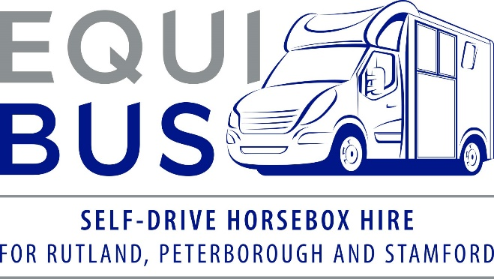

Hirer/Driver Information
A form must be completed by each hirer/driver
Hirer’s name
Hirer’s home address
How long have you lived at this address? | Years Months
Date of birth
Nationality
Occupation
Contact details | Mobile No.
Contact details | Home No.
Contact details | Email address

Journey Details
Date/s of hire | Collection location – please circle or delete as appropriate  - Manor Farm, LE15 7DH  - Wittering Grange, PE8 6NR
Date/s of hire | Collection date
Date/s of hire | Return date
Preferred collection time
Return time
Journey purpose
Intended destination
Estimated mileage
Number of horses to travel
Estimated weight of horse/s
If having the EquiBus overnight, where will it be parked?

Hirer/Driver License Information and Driving History
Country of issue of licence
Driving licence number
Date driving test passed
Driving licence categories held
How often do you drive?
Have you driven a 3.5t horsebox before?
Has your licence been suspended for any period in the last 3 years?
Have you been involved in more than one fault accident in the last 3 years?
Have you ever had motor insurance refused or declined?
Have you ever had motor insurance cancelled?
Has any insurer ever applied special terms to your motor insurance as a result of claims?
Have you had any non-motoring convictions?
Your DVLA access code | Code:
Your DVLA access code | Valid from:
The DVLA records motoring convictions electronically. We are required by our insurance provider to verify your licence details. In order to access this information, we require a one-time DVLA access code. To obtain the access code, please phone the DVLA on 0300 083 0013, or log in to the DVLA’s View Driving Licence Service on www.gov.ukcheck-driving-information (you will need your driving licence number and National Insurance No.)

Motoring Convictions
Do you have more than two convictions on your licence? | Y / N
Do you have more than 6 penalty points on your licence? | Y / N
Details of convictions in last 5 years  Please provide details for all convictions in this period | Date of offence
 | Date of conviction
 | Conviction code
 | Number of points
Fine value
£

Details of any motor vehicle claims, accidents, vehicle fires and thefts in last 3 years
Please confirm if you have any BA, DD or UT convictions | Y / N  Details:

Medical Conditions
Do you suffer from any of the medical conditions notifiable to the DVLA? | Y / N
As a result of these medical conditions, have any driving licence restrictions been placed on your licence? | Please detail…

Please use this space for any other information you would like to declare?

See over for declaration

DECLARATION
I declare that I have read and understood the above questions and have answered accurately and in full. I agree that the information supplied may be used to check my identity and my suitability to drive and may be shared with others to facilitate the arranging of insurance on my behalf and for the purposes and processing of insurance claims.
I further agree to be bound by the terms and conditions of hire, which I have seen and read or have had the opportunity to see and read.
I hereby confirm my understanding and agreement that I am liable for the insurance excess of (up to) £500.00 in the event that the vehicle is damaged whilst in my care.
I understand that subject to the provisions of the Data Protection Act 2018, I am entitled, on the payment of a small fee, to receive a copy of the information held about me.

Hirer/Driver's Signature ……………………………………………………………………………………………………..

Date of Signing ………………………………………………

